UDC 621.391

**MAPREDUCE CALCULATING MODEL ON MOBILE DEVICES**

**Alekseev N.O, Pavlenko V.M.**

*Institute of Telecommunication Systems,*

*Igor Sikorsky Kyiv Polytechnic Institute, Ukraine*

*E-mail*: [ghostor2011](mailto:ghostor2011)@gmail.com

**MapReduce обчислювальна модель на мобільних пристроях**

Ця стаття пояснює використання найновішої моделі програмування, яка робить велику кількість операцій обчислення паралельно на мобільних пристроях, де програма працює в пісочниці без особливих потреб і імітує мобільний як такий потужний, як ПК.

This article explain the use of the newest programming model that makes big number of operations calculating in parallel on mobile devices, where program runs in sandbox without specific needs and simulate mobile as powerful as PC.

The technology of distributed calculations are gaining popularity about 5 years already. It is caused by the global connection of a large number of computer devices to the Internet, which, in turn, allows the nodes to connect with each other. The idea is based on the statement, that modern electronic machines do not use the whole processor power of their core (RAM, main processor) and spend energy irrationally.. The vocation of such technology is the system's loading of various simple tasks during the downtime of the operating system, not blocking application software of root user at the same time. The task is performed as a low-priority background process, taking up to 10% of productivity at parallel work with processes on behalf of the user, and up to 45% when the operating system goes into standby mode.

The nodes, working within one project, receive tasks from the main server, which initially divides the complex task into parts, then sends it to the nodes for execution, and after a set time texec, begins to collect the processed information by nodes in a single response. The server itself is a unique link in the work of this technology, and needs fine tuning. Unlike it, working units can be different configuration and even do not know about the existence of each other. This architecture feature allows you to use not only commonly accepted desktops, but also other gadgets, equipped with 32 or 64 bit processors.

Choosing a mobile platform (mobile phones, tablets, smart watches) as nodes of the distributed calculated system has several advantages:

* High performance for simple tasks
* Gadget Mobility
* Simplicity of application settings and creation
* Ability to use a large number of nodes
* Permanent online status due to widespread 3G connection
* Lots of downtime (in standby mode)
* Ability to uniquely identify the node by the gadget parameters (IMEI, GUID, Serial Number, mobile operator card number).

Schematically, the Distributed Calculation System is a network of linked nodes and a server in the Internet, using the popular Http protocol. The system consists of a server, written and working on the Node.js technology, that simplifies the binding of nodes and work with the Internet protocols, and several nodes, connected via WiFi and 3G with various mobile operating systems (iOS and Android). The server, responsible for dividing, mailing and bonding a task, must have a reliable access to the Internet, because it also has to monitor the state of the node and the progress of the calculation. There is also a software snap-in on a mobile client, which carries out the acceptance of the task, sending for processing and formatting the response for further sending to the 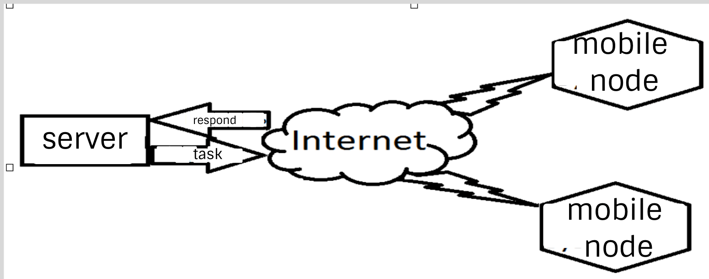main node.

Fig.1 Distributed Calculating Network Scheme for mobile nodes

After the dispatching of tasks and processing them on the nodes, the gluing to the general answer by the method, reversed to division of a task is performed on the server.

  The difference between these processes is that at the gluing stage the completeness and relevance of the data is also checked by the unique identifier of the device. This stage includes an analysis of the node's operation (availability of the online status) and the need to re-send the lost part of the response repeatedly to another free working node in case of a sudden disconnection of the previous node, engaged in processing this part of the task.

For such a system there has been developed an application on popular mobile platforms - iOS and Android - which can be downloaded from the app store for each operating system, in accordance. It is to perform data receiving, processing, sending and formatting in the form of an answer for easy gluing by the server.

Thus, the use of mobile devices to carry out bulky and long-term calculations as small and medium-sized networks has several advantages over the use of stationary computers, namely: longer downtime of the operating system and standby time, an easy access to the Internet, easiness of platform configuration for tasks execution, centralized distribution system.

**References**

1. Jeffry Dean and Sanjay Ghemawat (2014). MapReduce: Simplified Data Processing on Large Clusters. Google, Inc.

2. University of California, Barkeley. Source: http://wla.berkeley.edu/~cs61a/fa11/lectures/communication.html.

3. R. G. Gallager, P. A. Humblet, and P. M. Spira (January 1983). "A Distributed Algorithm for Minimum-Weight Spanning Trees".

4. Hamilton, Howard. "Distributed Algorithms". Retrieved 2013-03-03